Question 1 Calc Free (6marks)

After reading in the paper about the increased rate of criminal activity in beach suburbs, Freda decided to investigate some statistics for a popular beach suburb. She used data from the website for the Western Australia Police and examined the relationship between the number of assaults and the number of burglaries each month. Using a spreadsheet package she produced the following display.

(a) Describe the strength of the linear relationship between the two variables. Justify your conclusion. (2 marks)
(b) The linear relationship between the two variables is described by the equation provided.

(i) What does this equation indicate is the approximate number of burglaries in a given month when there are no assaults? (1 mark)

(ii) What does this equation indicate would be the rate of change in the number of burglaries as the number of assaults increase? (3 marks)

Solutions Question 1 Calc Free (6marks)

Question 1 (a)
Solution

The relationship is weak. The correlation coefficient is about 0.45 OR the data points do not form a close linear pattern.
Marking key/mathematical behaviours | Marks
- describes the strength of the linear relationship  - justifies conclusion | 1  1

Question 1 (b)
Solution

(i) There would be about 10 burglaries
(ii) As the number of assaults increases by 1 the number of burglaries decreases by 1.
Marking key/mathematical behaviours | Marks
- interprets the y-intercept  - describes the change as negative  - identifies the rate of change as 1 for 1 [1 mark for each value] | 1  1  2

Question 2 Calc Assumed (14 marks)

The amounts of total fat and total carbohydrate per 100 g for nine different packets of biscuits are recorded in the table provided.
Total fat | 18 | 23 | 20 | 7 | 3 | 1 | 8 | 12 | 18
Total Carbohydrate | 61 | 59 | 71 | 74 | 72 | 82 | 85 | 75 | 66

(a) Create a labelled scatter plot to show the relationship between the two variables using total fat as the explanatory variable. (6 marks)
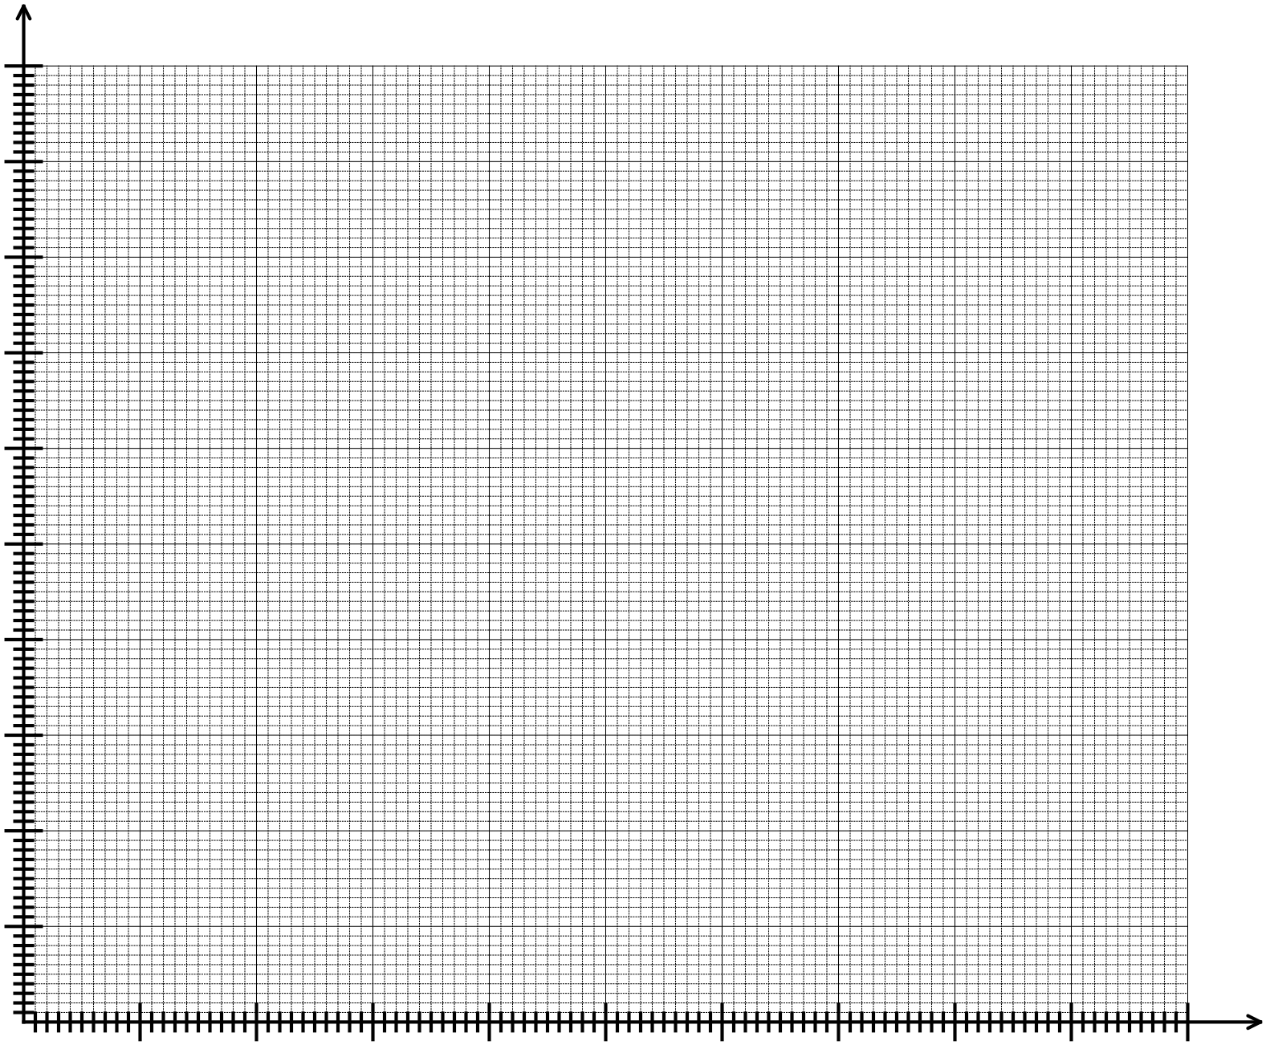
(b) Determine the
(i) equation of the least squares line that models the linear relationship between the two variables.
(2 marks)
(ii) correlation coefficient. (1 mark)
(c) Use your equation from part (b) to predict the total carbohydrate per 100 g for a packet of biscuits in which the total fat per 100 g is 30. (2 marks)
(d) Describe the reliability of your prediction in part (c) and give two reasons to justify your conclusion. (3 marks)

Solutions Question 2 Calc Assumed (14 marks)
Question 2(a)
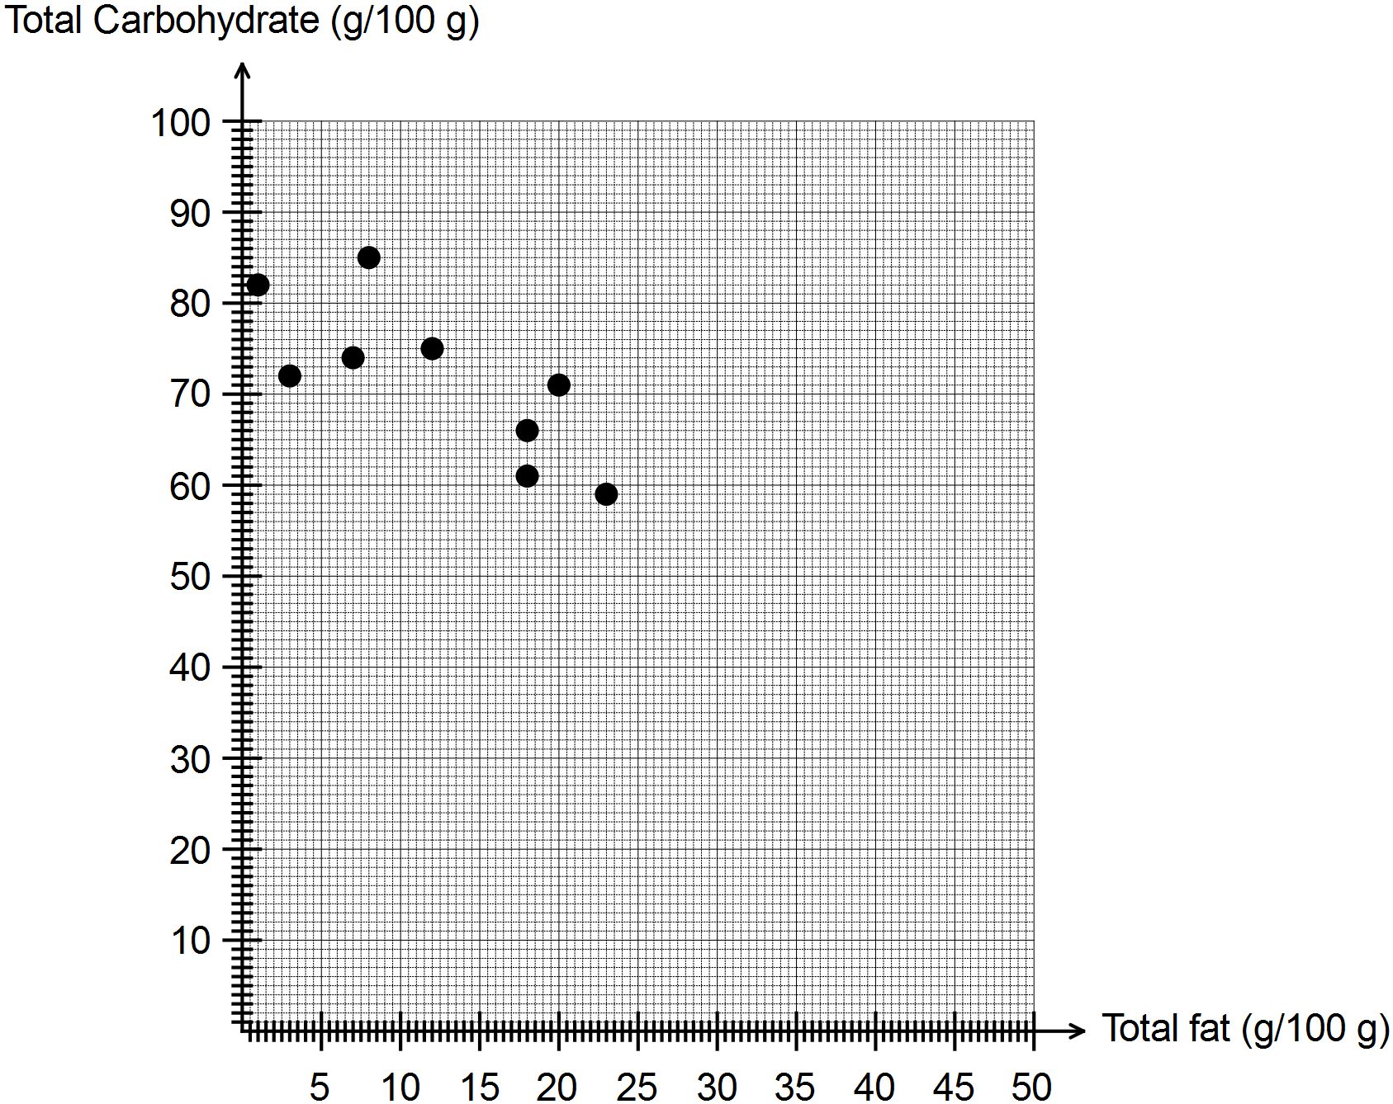
Marking key/mathematical behaviours | Marks
- allocates total fat to horizontal axis  - labels both axes with correct variables  - scales both axes accurately  - selects correct type of graph  - plots any 5 points correctly  - plots remaining 4 points correctly | 1  1  1  1  1  1
Question 2 (b)
(i) Total carbohydrate = -0.849 x total fat + 82.048
(ii) r = -0.77
Marking key/mathematical behaviours | Marks
- determines gradient and intercept on vertical axis for regression line  - identifies variables in regression line  - determines correlation coefficient | 1  1  1
Question 2 (c)
Total carbohydrate = -0.849 x total fat + 82.048 = -0.849 x 30 + 83.048 = 57.6 g per 100 g
Marking key/mathematical behaviours | Marks
- substitutes correctly into equation of line from (b)  - determines total carbohydrate | 1  1
Question 2 (d)
Prediction is fairly reliable. It is made from within the data set – ie interpolated AND the correlation coefficient is much nearer -1 than 0
Marking key/mathematical behaviours | Marks
- identifies strength of the prediction  - gives one reason to justify prediction  - gives second reason to justify prediction | 1  1  1

Question 3 Calc Assumed (8 marks)

Alex is interested in investigating the time it takes for a student in Year 12 to obtain a driver’s licence. He decides to survey the members of his football team to collect the data he needs.
(a) Suggest one way he could improve his data collection. (1 mark)

(b) Obtaining a driver’s licence consists of several activities and Alex decides to concentrate on studying the time a student spends driving a car with a supervisor before taking the Practical Driving Assessment (PDA). Determine an appropriate question for the survey. (1 mark)

Bill conducted a similar survey in his Applications class and the students approximated the number of hours they spent driving a car with a supervisor before taking the PDA. They gave their results to the nearest 5 hours. The results are provided in the table below.

Number of hours | Frequency
25 | 5
30 | 10
35 | 1
40 | 2
45 | 0
50 | 2

(c) Describe TWO ways by which Bill could have obtained more useful data. (2 marks)

(d) Provide TWO conclusions that can be made from Bill’s results. For each statement provide statistics to justify these conclusions. (4 marks)

Solutions Question 3 Calc Assumed (8 marks)
Question 3 (a)
Survey more people OR Survey a greater variety of people
Marking key/mathematical behaviours | Marks
- suggests improvement for data collection | 1
Question 3 (b)
How many hours did you spend driving a car before you sat the Practical Driving Assessment?
Marking key/mathematical behaviours | Marks
- determines an appropriate survey question | 1
Question 3 (c)
Collect data to the nearest hour
Collect data from more people
Get the students to keep a driving log
Collect data from a greater range of students
Marking key/mathematical behaviours | Marks
- identifies two ways to improve the data collection | 2
Question 3 (d)
The mode is 30 and so is the median. Thirty hours is a typical time for these students to spend on driving before sitting the PDA.
The maximum score was 50, this is the most number of hours any student spent driving before the PDA.
The minimum number of hours of driving before the PDA was 25 – it is the lowest score.
Marking key/mathematical behaviours | Marks
- interprets the frequency table provided, drawing conclusions and uses data to justify these conclusions. | 2  2

Question 4 Calc Assumed (10 marks)
In the CensusAtSchool survey in 2013, respondents were asked the following question:
“How do you usually spend your time on the internet?” The tables below show the percentages of students who selected each of the categories never, rarely, sometimes and often for six uses of the internet.
FEMALES
 | Shopping |  | Email |  | Games | Research | Browsing | Social networking
never | 53.6 |  | 20.5 |  | 20.5 | 4 | 7.5 | 18.1
rarely | 27.9 |  | 38.3 |  | 34.6 | 21.1 | 28.8 | 10.4
sometimes | 13.6 |  | 27.5 |  | 26.2 | 47.9 | 43.3 | 19.3
often | 4.8 |  | 13.6 |  | 18.7 | A | 20.4 | 52.3
MALES
 |  | Shopping |  | Email | Games | Research | Browsing | Social networking
never |  | 46.9 |  | 31.6 | 7 | 10.9 | 10 | 23.9
rarely |  | 30.9 |  | 37.6 | 17.6 | 28.8 | 26.7 | 15.4
sometimes |  | 15.6 |  | 21.3 | 28.2 | 42.8 | 41.6 | 23.1
often |  | 6.7 |  | 9.5 | 47.3 | 17.4 | 21.7 | 37.6
(a) Calculate the value represented by A. (1 mark)
(b) Explain why the sum of the percentages of females using the internet to shop in each of the categories is not equal to 100%. (1 mark)
(c) Use the data to identify the least popular of these internet uses among the female respondents to the survey. (1 mark)
(d) Use the data to identify the most popular of these internet uses among the male respondents to the survey. (1 mark)
(e) Describe TWO ways in which the use of the internet for email by male and female respondents are different and provide data from the table to justify your conclusion. (2 marks)
(f) The percentages of female and male respondents using the internet for browsing were 92.5% and 90% respectively. This does not indicate that the number of times the internet was used for browsing by females responding to the survey was greater than the number of times for male respondents. Give two reasons to justify this conclusion. (2 marks)
(g) Consider the following statement:
Female respondents spent more time using the internet for social networking than male respondents did.
State whether the conclusion is definitely TRUE, definitely FALSE or NOT SUPPORTED and justify your decision. (2 marks)
Solutions Question 4 Calc Assumed (10 marks)
Question 4 (a)
A = 100 – 4 – 21.1 – 47.9 = 27 or 27%
Marking key/mathematical behaviours | Marks
- determines remaining percentage | 1
Question 4 (b)
Data have been rounded
Marking key/mathematical behaviours | Marks
- identifies cause of incorrect total | 1
Question 4 (c)
Shopping
Marking key/mathematical behaviours | Marks
- interprets data in table | 1
Question 4 (d)
games
Marking key/mathematical behaviours | Marks
- interprets data in table | 1
Question 4 (e)
A higher proportion of the males surveyed never use the internet for email i.e 31.6% males compared to 20.5% of the females. A higher proportion of females use the internet for email often i.e. 13.6% of females compared to 9.5% of the males.
Marking key/mathematical behaviours | Marks
- provides an accurate statement of proportion and provides data to support the statement  - provides a second accurate statement of proportion and provides data to support the statement. | 1  1
Question 4 (f)
There could have been more males in the survey and 90% of this number may have been greater than the 92.5%.
The respondents were left to interpret the descriptors of rarely, sometimes and often so there is no indication in the data about the number of times respondents used the internet.
Marking key/mathematical behaviours | Marks
- gives one reason to support the conclusion provided  - gives a second reason to support the conclusion provided | 1  1
Question 4 (g)
NOT SUPPORTED - The survey did not collect data about the amount of time, only the proportion of users so it is not known how much time people spent on the internet.
Marking key/mathematical behaviours | Marks
- selects correct option  - recognises the limitation of the data | 1  1

SolutionsQuestion 5 Calc Assumed (12 marks)
The points on the graph below represent the cost of an economy one-way flight ($) and the flying distance (km) to various holiday destinations. Use the data for the questions to follow.

(a) What was the cost of the most expensive flight? (1 mark)
(b) Identify the response variable. (1 mark)
(c) Circle the data point representing the city which is a flying distance of 6000 km and for which a ticket costs $472. (1 mark)
One outlier was removed and then the following statistics were calculated
The coefficient of determination: r² = 0.9538
Equation for the least squares line: Cost ($) = 0.103 x distance – 7.166
(d) Determine the percentage of variation in cost that can be explained by the change in distance.
(1 mark)
(e) Calculate the correlation coefficient. (1 mark)
(f) Which of the values, 0.88 or 0.98 is more likely to have been the coefficient of determination before the outlier was removed? Explain your decision. (2 marks)
For a city located at a distance of approximately 10 000 km,
(g) use the equation provided to predict the cost of a one-way economy flight. (2 marks)
(h) plot the data point on the graph above. (1 mark)
(i) describe the reliability of your prediction to part (g) and justify your conclusion.
(2 marks)

Question 5 Calc Assumed (12 marks)
Question 5 (a)
$1800
Marking key/mathematical behaviours | Marks
- reads scatter plot | 1
Question 5 (b)
Cost of flight
Marking key/mathematical behaviours | Marks
- identifies response variable | 1
Question 5 (c) & (h)
Marking key/mathematical behaviours | Marks
- (c) identifies data point – circled  - (d) plots data point – red dot | 1  1
Question 5 (d)
95.4%
Marking key/mathematical behaviours | Marks
- identifies coefficient of determination | 1
Question 5 (e)
r = 0.9766
Marking key/mathematical behaviours | Marks
- calculates correlation coefficient | 1
Question 5 (f)
0.98. It was 0.9538 after the outlier was removed and would have been higher prior to that.
Marking key/mathematical behaviours | Marks
- identifies correct value for coefficient of determination  - justifies choice | 1  1
Question 5 (g)
Cost = 0.103 x 10000 – 7.166 = $1023
Marking key/mathematical behaviours | Marks
- shows substitution into the equation provided  - determines predicted cost | 1  1
Question 5 (i)
The prediction is very reliable. The correlation coefficient is very close to 1 (0.9766)
Marking key/mathematical behaviours | Marks
- describes prediction  - justifies conclusion | 1  1
Question 6 Calc Assumed (6 marks)
On the graph below the horizontal axis represents the percentage of students “doing Vet” and the vertical axis represents the percentage of students receiving “an ATAR”. Each point represents a different school. The data was sourced from tables published in the West Australian newspaper in January 2016.

(a) Describe what tends to happen to the percentage of students receiving an ATAR as the percentage of students “doing Vet” increases. (1 mark)
(b) What do the following features of the pattern of the dots indicate about the nature of the relationship between the two variables? (3 marks)
(i) The dots are heading in a downwards direction.
(ii) The dots are nearly in a straight line.
(iii) The dots are close together.
(c) Consider and explain possible causes of the relationship between the two variables.
(2 marks)

Solutions Question 6 Calc Assumed (6 marks)
Question 6 (a)
It decreases
Marking key/mathematical behaviours | Marks
- interprets relationship between variables | 1

Question6 (b)
(i) relationship is negative
(ii) relationship is linear
(ii) relationship is strong
Marking key/mathematical behaviours | Marks
- interprets negativity of relationship  - interprets linearity of relationship  - interprets strength of relationship | 1  1  1

Question 6 (c)
Generally speaking students did ATAR or VET in 2015 so the percentages added up to about 100%. Some students achieved both (over 100% in some schools) and some achieved neither (less than 100%). One variable does not cause the other but there is a very strong association between them because students do not tend to choose to do both as the time to do both is limited.
Marking key/mathematical behaviours | Marks
- indicates variables are complementary  - describes lack of causality | 1  1

Question 7 Calc Assumed (7 marks)

The value of the correlation coefficient between two variables X and W is –0·95, and the value
of the correlation coefficient between two variables Z and W is 0·63.

(a) As the values of X increase, how do the values of W change? (1 mark)

(b) Which pair of variables shows the stronger correlation?
Explain very briefly. (2 marks)

(c) (i) Calculate r_{zw}². State your answer correct to 3 decimal places. (1 mark)

(ii) What information about variation does r_{zw}² provide? (2 marks)

(d) If it was necessary to predict a value for W, which variable would be more useful
to predict from? (1 mark)

Solutions Question 7 Calc Assumed (7 marks)

(a) W decreases

(b) X and W because | − 0.95 | > | 0.63 |

(c) (i) 0.3969
(ii) It says that 39.69 % of the variation in one is associated
with the change in the other

(d) X, since the correlation is stronger.
[7]

Question 8 Calc Assumed (10 marks)
Roe (eggs) collected from Salmon are considered a delicacy by some people.

Seven salmon, all with roe, are used to analyse the relationship between weight of a salmon, in kg,
and the weight of its roe, in grams. The resulting data are recorded in the table below.

X | Weight of  Salmon (kg) | 1.2 | 1.6 | 1.7 | 1.8 | 1.9 | 2.1 | 2.2
Y | Weight of Roe (g) | 42 | 45 | 46 | 50 | 53 | 56 | 54

(a) Show the data on the axes below. (2 marks)

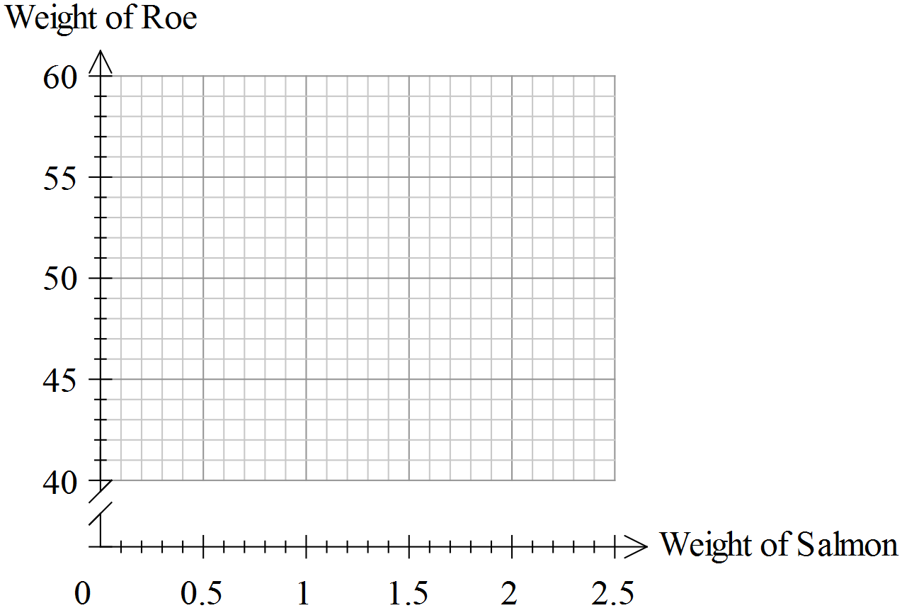

(b) (i) State the equation of the regression line of Y on X. (1 mark)

(ii) State the correlation coefficient linking X and Y. (1 mark)

(iii) Which variable is called the response variable? (1 mark)

(c) Predict the weight of roe from a salmon whose weight is 2 kg. (1 mark)

You are asked to predict the weight of roe from a salmon whose weight is 750g.

(d) Comment on this request. (2 marks)

The equation tells us the average rate of increase in the weight of roe for each kilogram
increase in the weight of the salmon.

(e) What is that average rate of increase? (1 mark)

The researcher concludes that it is the increase in weight of the salmon which causes the
increase in the weight of roe.

(f) Why is his claim not statistically correct? (1 mark)
Solutions Question 8 Calc Assumed (10 marks)
(a)
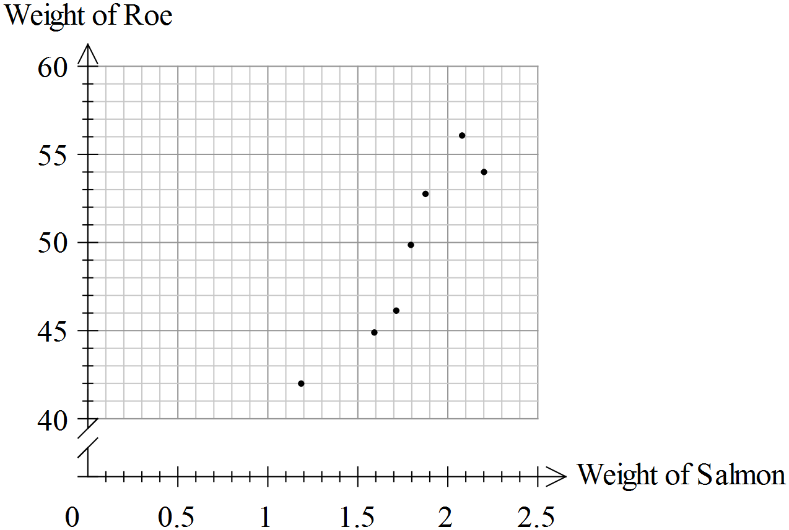

(b) (i) 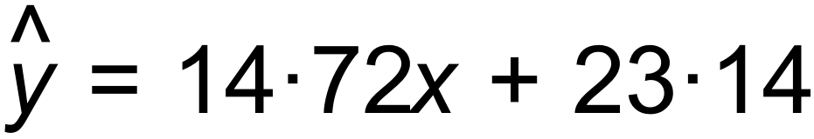
(ii) 0.94
(iii) Y

(c) x = 2 means y = 52.6

(d) It is an extrapolation, so likely to be unreliable.

(e) 14.72 g per kg.

(f) High value of r does not mean a cause/effect relationship. [10]

Question 9 Calc Assumed (6 marks)

Some data was collected and graphed. The graph is given below.

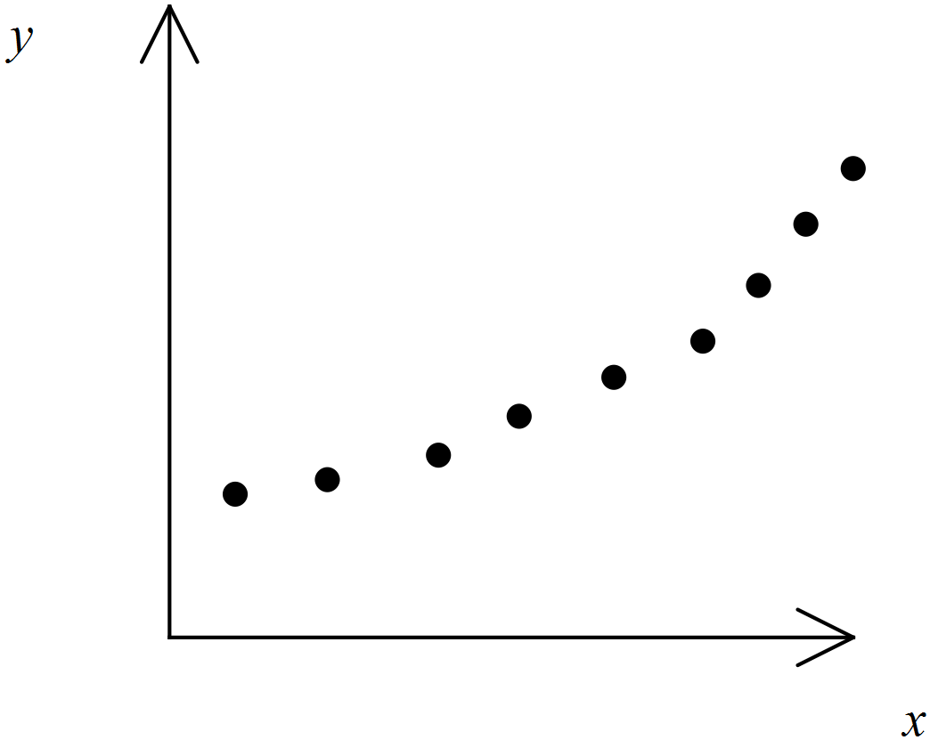

A line is used to model the data.
The equation for model A is 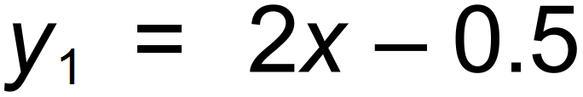 for 1 ≤ x ≤ 10
An exponential model is also used for the same domain.
The equation for model B is 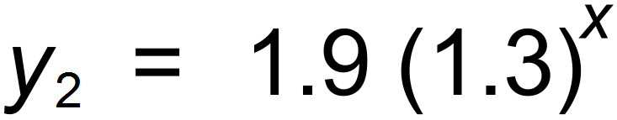
Both models have a strong positive correlation.
(a) If x = 8,
(i) predict the value of y for model A, correct to 1 decimal place. (1 mark)

(ii) predict the value of y for model B, correct to 1 decimal place. (1 mark)

(iii) comment on the reliability of your predictions above. (2 marks)

The graph of the residuals for the linear model shows an obvious pattern.

(b) Which of the two models is likely to be more appropriate to use for predictions
for values of x > 10? Give a reason related to the residual graph. (2 marks)

Solutions Question 9 Calc Assumed (6 marks)

a) (i) 15.5
(ii) 15.5
(iii) Both are reliable, since correltion is strong
and 8 is an interpolation.

(b) The pattern indicates that the linear model may not be appropriate.
So the geometric( exponential) may be better. [6]

Solutions Question 10 Calc Assumed (6 marks)

The students at an international college were surveyed about their preferences for University
or TAFE, and their country of origin. The results are given in percentage terms in the table below.
The percentages have been rounded.

Country of Origin | University in WA | University elsewhere | TAFE
China | 70 | 26 | 4
Malaysia | 75 | 20 | 5
South Africa | 60 | 10 | 30
India | 70 | 30 | x
England | 100 | 0 | 0
Indonesia | 50 | y | 10

The numbers of students who took part in the survey are shown in the table below.

Country of Origin | Number of Students
China | 120
Malaysia | 40
South Africa | 16
India | 50
England | 1
Indonesia | 20

(a) Calculate the values of x and y (1 mark)

(b) How many international students took part in the survey? (1 mark)

(c) What percentage of the students who took part were from China? (1 mark)

(d) Which country had the lowest number of students wishing to go to University in WA? (1 mark)

(e) How many students who took part wanted to go to TAFE? (2 marks)

Solutions Question 10 Calc Assumed (6 marks)

(a) x = 0, y = 40%

(b) 247

(c) 48.6%

(d) England (1)

(e) ( 0.04 x 120 ) + ( 0.05 x 40 ) + ( 0.3 x 16 ) + ( 0.1 x 20 )
= 14 students [6]

Question 11 Calc Free (6 marks)

A survey was being conducted at a local shopping centre one Saturday morning.
The question being asked was “How often do you visit this shopping centre?”
A set of 3 possible answers were Daily, Twice per week, Once per week.
It was hoped that the information would inform the allocation of staff at peak times during
the 7 day week.

(a) Suggest two ways in which the survey could be improved. (2 marks)

The interviewer asked as many women as she could during that Saturday morning.
She did not ask any men.

(b) Suggest two reasons why the shopping centre management would be unhappy
with that method of data collection. (2 marks)

The results were put into a pi chart as shown.
There were 40 women who said they shopped once per week.

(c) How many women said they shopped there daily? (1 mark)
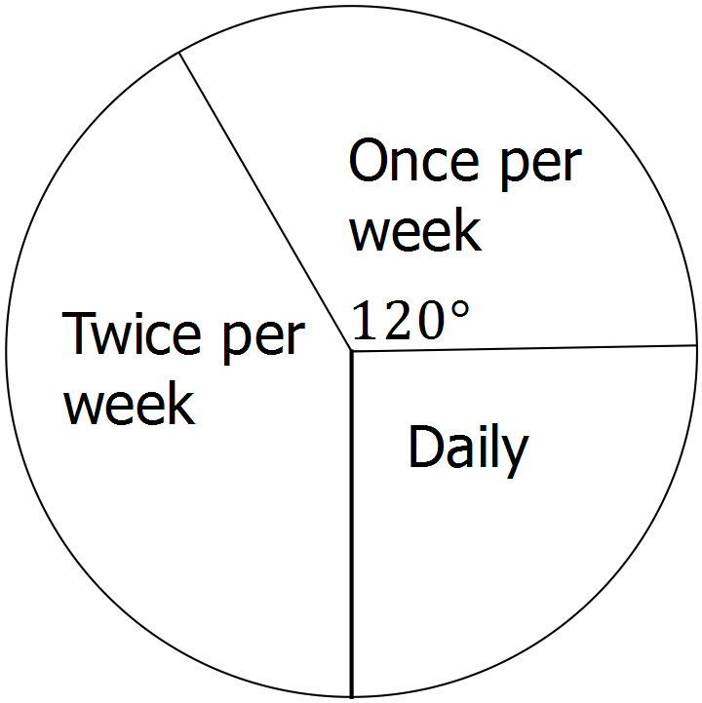

(d) How many women were surveyed? (1 mark)

Solutions Question 11 Calc Free (6 marks)

(a) Not just Saturday mornings.
More answer options.
Questions about times of day when shopping is done.

(b) Men might do shopping on Saturday mornings to give their partners a break
Some men are stay at home “mums” and always do the shopping.
Women might do their shopping at night, if they work during the day.

(c) 30

(d) 3 x 40 = 120 [6]

Question 12 Calc Assumed (9 marks)

Solutions Question 12 Calc Assumed (9 marks)

- 45 Minutes

- 3 Teams

- As the male times increase so the female times tend to increase

- $m,$ the male times.

- $r^{2}=0.7396,$ and so approximately 74% of the variation can be explained in this way.

- $f=0.635\left(52\right)+13.55=46.57≈47$minutes

- $f=0.635\left(65\right)+13.55=54.825≈55$minutes

- The first prediction of 52 minutes, as it involves interpolation whereas the second involves extrapolation and so is unreliable.

Question 13 Calc Assumed (8 marks)

Solutions Question 13 Calc Assumed (8 marks)

Question 14 Calc Assumed (8 marks)

Solutions Question 14 Calc Assumed (8 marks)

- $r=-0.956$

- The association is strong (correlation is close to -1) and negative (as time increase, number smoked tends to decrease).

- $n=-0.3603t+734.23$

- The average number of cigarettes smoked per week by people in this age group is decreasing by an average of 0.36 per year.

- $y=-0.3603\left(2016\right)+734.23=7.9$
From least squares line, expect close to 8 cigarettes per week, but prediction involves extrapolation and so should be treated with caution.

